Postal Life Insurance

Department of Post

Software Requirements Specification (SRS)/ Functional Requirements Specification (FRS)
  - e-IA Integration

INTERNAL APPROVAL FORM

Project Name: e-IA Integration
Version: 1.0
Submitted on:
 | Name | Date
Approved By:
Reviewed By:
Prepared By:

VERSION CONTROL LOG
Version | Date | Prepared By | Remarks
1

Table of Contents

1. Executive Summary 4
2. Project Scope 4
3. Business Requirements 4
4. Functional Requirements Specification 5
4.1 Policy Linkage API 6
4.2 Policy Publish API 6
4.3 Policy Update Event API 8
4.4 Servicing Update API 8
4.5 Linkage Status Query API 9
4.6 Repository Porting API 10
4.7 Error & Dead-Letter (DLQ) API 11
4.8 Document Access API 11
4.9 Health/Status API 12
4.10 Authentication (Token) API 12
4.11 Refund/Reconciliation API (Optional for Payment-related Sync) 13
5. Attachments 14

1. Executive Summary
This document outlines the requirements for integrating the Insurance Management System (IMS) of India Post PLI with the National Insurance Register (e-IA). An e‑Insurance Account (e‑IA) is a digital repository introduced under IRDAI to store and manage all insurance policies of an individual (life, health, general, pension) in electronic form through authorized repositories. Integration will enable the users to:
- Digitize policy issuance & servicing (paperless).
- Offer a unified customer interface across repositories.
- Ensure secure, compliant, real‑time exchange of policy/KYC/service data.

2. Project Scope
This Module will:
- Policy Linkage: Link existing PLI policies to a customer’s e‑IA (any repository).
- New Issuance: Deliver newly issued PLI policies directly to e‑IA (e‑policy).
- Updates & Servicing: Synchronize customer KYC, contact data, nominee, bank details, endorsements, premium status, loan/lien, revival, surrender, claims.
- Status & Notifications: Provide event updates to repositories and receive acknowledgements/errors.
- Porting: Support repository migration (e.g., CAMS→NSDL) with continuity.
- Consent & Data Privacy: Manage customer consent, repository authorization, audit logs.
- Reporting: Regulatory, operational, and reconciliation reports; dashboards.

3. Business Requirements

ID | Requirements
FS_EIA_001 | Enable secure linkage of PLI policies to customer e-Insurance Accounts across all IRDAI-approved repositories with consent validation.
FS_EIA_002 | Publish complete policy data and signed e-policy documents to repositories for digital access and compliance.
FS_EIA_003 | Synchronize servicing updates and status changes bi-directionally between IMS and repositories with event tracking.
FS_EIA_004 | Ensure end-to-end security, privacy, and IRDAI-compliant data handling including encryption, consent, and India-only storage.
FS_EIA_005 | Provide operational reports, reconciliation mechanisms, and refund workflows for payment and data mismatches.
FS_EIA_006 | Maintain high system reliability, performance, and observability with support for retries, DLQ, and outage resilience.

4. Functional Requirements Specification
Use Case Diagram for e-IA Integration: 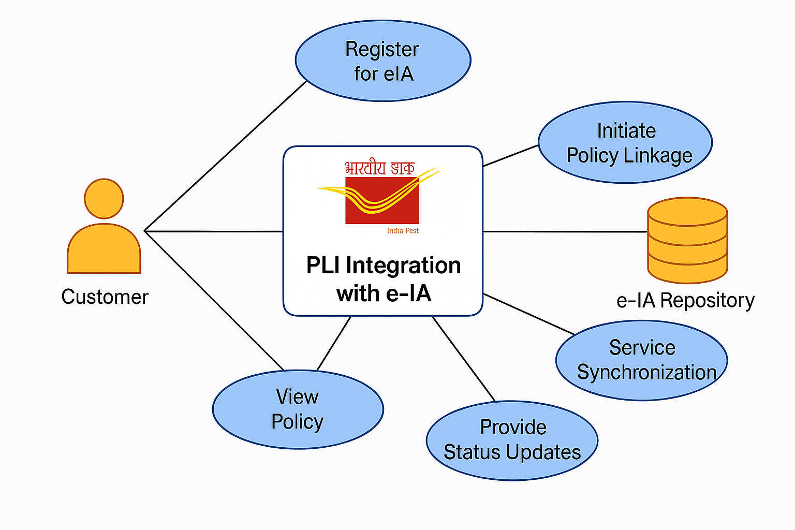
Flow Chart for e-IA and India Post PLI Integration: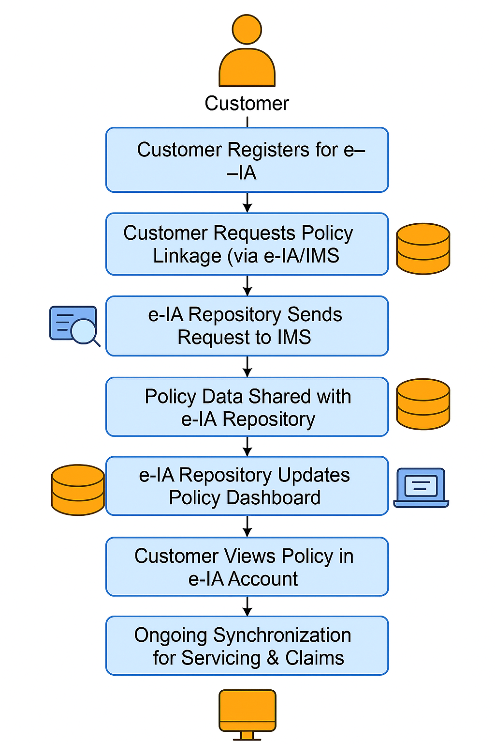

4.1 Policy Linkage API
- Purpose: To initiate linkage of a PLI policy with a customer’s e-Insurance Account (e-IA) through an IRDAI-approved repository.

4.1.1 Request Structure (Repository → IMS: Policy Linkage API)
Field Name | Type | Description
eiaNumber | String | Unique e-Insurance Account number
repositoryCode | String | Code of the repository (NSDL_NIR / CDSL_IR / CAMSREP / KARVY)
policyNumber | String | Unique PLI policy number
customerName | String | Full name of the policyholder
dob | Date | Date of birth of the policyholder (YYYY-MM-DD)
mobile | String | Registered mobile number
email | String | Registered email ID
panMasked | String | Masked PAN (e.g., ABCDE1234X)
aadhaarMasked | String | Masked Aadhaar (e.g., XXXX-XXXX-1234)
consentToken | String | JWT token indicating customer consent and scope (e.g., linkage)
requestedAt | DateTime | Timestamp of request in ISO 8601 format

4.1.2 Response Structure (IMS → Repository: Policy Linkage API)
Field Name | Type | Description
linkageRequestId | String | Unique ID for the linkage request
status | String | Request status (VALIDATION_IN_PROGRESS / LINKED / FAILED)
estimatedCompletion | DateTime | Estimated completion time (if applicable)
message | String | Status message or error description

4.2 Policy Publish API
- Purpose: To publish the full Policy Data Pack (including e-policy PDF reference) from IMS to the repository after successful validation.

4.2.1 Request Structure (IMS → Repository: Policy Publish API)
Field Name | Type | Description
linkageRequestId | String | ID of the linkage request that passed validation
policyNumber | String | Unique PLI policy number
productCode | String | PLI product code (e.g., PLI_WHOLE_LIFE)
sumAssured | Number | Sum assured amount
issueDate | Date | Policy issue date (YYYY-MM-DD)
termYears | Integer | Policy term in years
premiumMode | String | Premium mode (MONTHLY / QUARTERLY / HALF_YEARLY / YEARLY)
status | String | Current policy status (IN_FORCE / LAPSED / REVIVED / SURRENDERED / MATURED)
premiumSchedule | Array | Array of premium items (dueDate, amount, status)
riders | Array | Rider details, if any
loanAmount | Number | Current policy loan amount (0 if none)
nominees | Array | Nominee set (name, relationship, sharePct, minorGuardian)
contactMobile | String | Registered mobile
contactEmail | String | Registered email
ePolicyPdfUrl | String | Time-bound signed URL to e-policy PDF
soaPdfUrl | String | Time-bound signed URL to Statement of Account PDF
documentHashes | Object | SHA-256 hashes for PDFs (ePolicyPdfSha256, soaPdfSha256)
payloadSignature | String | JWS signature for payload integrity
publishedAt | DateTime | Timestamp of publish in ISO 8601 format

4.2.2 Response Structure (Repository → IMS: Policy Publish API)
Field Name | Type | Description
linkageId | String | Unique linkage ID created by repository
status | String | Repository status (LINKED / DUPLICATE / FAILED)
dashboardUrl | String | Repository dashboard URL for the policy
message | String | Status or error description

4.3 Policy Update Event API
- Purpose: To notify the repository of policy servicing changes (status updates, endorsements, payments, claims status, etc.).

4.3.1 Request Structure (IMS → Repository: Policy Update Event API)
Field Name | Type | Description
eventId | String | Unique event identifier
eventType | String | Event type (POLICY_UPDATED / PAYMENT_POSTED / CLAIM_STATUS_CHANGED / ENDORSEMENT_ADDED / NOMINEE_CHANGED / PORTED / ERROR)
policyNumber | String | Unique PLI policy number
changes | Object | Delta object describing the change (e.g., status old/new, fields changed)
occurredAt | DateTime | Event time in ISO 8601 format
payloadSignature | String | JWS signature for integrity

4.3.2 Response Structure (Repository → IMS: Policy Update Event API)
Field Name | Type | Description
accepted | Boolean | Whether the event was accepted for processing
eventId | String | Echoed event ID for correlation
message | String | Acceptance info or reason for rejection

4.4 Servicing Update API
- Purpose: To submit customer-initiated servicing updates (e.g., nominee change, contact change, bank account updates) from repository to IMS.

4.4.1 Request Structure (Repository → IMS: Servicing Update API)
Field Name | Type | Description
eiaNumber | String | Unique e-Insurance Account number
repositoryCode | String | Repository code (NSDL_NIR / CDSL_IR / CAMSREP / KARVY)
policyNumber | String | Unique PLI policy number
updateType | String | Type of update (NOMINEE_CHANGED / CONTACT_CHANGED / BANK_CHANGED / ENDORSEMENT_REQUEST)
payload | Object | Update payload (e.g., nominees array, new contact details)
consentToken | String | JWT token confirming customer consent for the specific update
requestedAt | DateTime | Timestamp in ISO 8601 format

4.4.2 Response Structure (IMS → Repository: Servicing Update API)
Field Name | Type | Description
servicingRequestId | String | Unique servicing request ID
status | String | Status (QUEUED / IN_PROGRESS / COMPLETED / REJECTED)
slaSeconds | Integer | Expected processing SLA in seconds
message | String | Status message or rejection reason

4.5 Linkage Status Query API
- Purpose: To query linkage status for a given policy number.

4.5.1 Request Structure (Repository → IMS: Linkage Status Query API)
Field Name | Type | Description
policyNumber | String | Unique PLI policy number

4.5.2 Response Structure (IMS → Repository: Linkage Status Query API)
Field Name | Type | Description
policyNumber | String | Unique PLI policy number
eiaNumber | String | Linked e-IA number (if any)
repositoryCode | String | Repository code
status | String | Linkage status (LINKED / NOT_LINKED / PENDING / FAILED)
linkedAt | DateTime | Linkage timestamp (if LINKED)
message | String | Additional info

4.6 Repository Porting API
- Purpose: To port policy linkages from one repository to another with customer consent.

4.6.1 Request Structure (New Repository → IMS: Repository Porting API)
Field Name | Type | Description
fromRepositoryCode | String | Source repository code
toRepositoryCode | String | Destination repository code
eiaNumber | String | e-IA number to be ported
policyNumbers | Array | Array of policy numbers to port
consentToken | String | JWT token indicating explicit consent for porting
requestedAt | DateTime | Timestamp in ISO 8601 format

4.6.2 Response Structure (IMS → New Repository: Repository Porting API)
Field Name | Type | Description
portingRequestId | String | Unique porting request ID
status | String | Status (INITIATED / COMPLETED / PARTIAL / FAILED)
portedPolicies | Array | Array of objects (policyNumber, status)
message | String | Status or error description

4.7 Error & Dead-Letter (DLQ) API
- Purpose: To record and fetch unrecoverable messages/events for manual reconciliation.

4.7.1 Request Structure (IMS → Repository: DLQ Submit API)
Field Name | Type | Description
dlqId | String | Unique DLQ record ID
source | String | Source component (EVENT_BUS / POLICY_PUBLISH / SERVICING_UPDATE)
policyNumber | String | Policy number involved (if any)
payload | Object | Original message payload (sanitized)
errorCode | String | Error code (SCHEMA_INVALID / AUTH_FAILURE / CONSENT_EXPIRED / REPO_DOWN / TIMEOUT)
errorMessage | String | Error description
failedAt | DateTime | Timestamp in ISO 8601 format

4.7.2 Response Structure (Repository → IMS: DLQ Submit API)
Field Name | Type | Description
accepted | Boolean | Whether DLQ record is stored
dlqId | String | Echoed DLQ ID
message | String | Storage status info

4.8 Document Access API
- Purpose: To fetch time-bound, signed URLs to e-policy and statement documents.

4.8.1 Request Structure (Repository → IMS: Document Access API)
Field Name | Type | Description
policyNumber | String | Unique PLI policy number
documentType | String | Type (E_POLICY_PDF / SOA_PDF)
requestedAt | DateTime | Timestamp in ISO 8601 format

4.8.2 Response Structure (IMS → Repository: Document Access API)
Field Name | Type | Description
url | String | Time-bound signed URL (validity ≤ 15 minutes)
sha256 | String | SHA-256 hash of the document
expiresAt | DateTime | URL expiry timestamp
message | String | Status or error description

4.9 Health/Status API
- Purpose: To check the readiness and health of the integration endpoints.

4.9.1 Request Structure (Repository → IMS: Health/Status API)
Field Name | Type | Description
correlationId | String | Optional correlation ID for tracing

4.9.2 Response Structure (IMS → Repository: Health/Status API)
Field Name | Type | Description
status | String | Overall status (UP / DEGRADED / DOWN)
components | Array | Component status array (API_GATEWAY, DOC_SERVICE, EVENT_BUS)
timestamp | DateTime | ISO 8601 timestamp
message | String | Diagnostic info

4.10 Authentication (Token) API
- Purpose: To obtain OAuth2 access tokens for secured API calls.

4.10.1 Request Structure (Repository → IMS: Token API)
Field Name | Type | Description
grantType | String | Must be client_credentials
clientId | String | Repository client ID
clientSecret | String | Repository client secret
scope | String | Requested scopes (e.g., linkage publish events)

4.10.2 Response Structure (IMS → Repository: Token API)
Field Name | Type | Description
accessToken | String | Bearer JWT token
tokenType | String | Constant Bearer
expiresIn | Integer | Token expiry in seconds
scope | String | Granted scopes

4.11 Refund/Reconciliation API (Optional for Payment-related Sync)
- Purpose: To reconcile payment events or initiate corrections (e.g., posted premium mismatches seen in e-IA vs IMS).

4.11.1 Request Structure (Repository → IMS: Refund/Reconciliation API)
Field Name | Type | Description
transactionId | String | Unique transaction ID (from repository or IMS)
reason | String | Reason for reconciliation (POSTING_MISMATCH / DUPLICATE / REVERSAL)
ts | DateTime | Timestamp in ISO 8601 format

4.11.2 Response Structure (IMS → Repository: Refund/Reconciliation API)
Field Name | Type | Description
reconId | String | Unique reconciliation ID
status | String | Status (INITIATED / COMPLETED / REJECTED)
expectedCompletion | DateTime | Expected completion date/time
message | String | Status message

5. Attachments
The following documents can be referred.

